You Can Never Have Too Many Bulbs for a Pollinator Garden!

From late winter to fall, bulbs are an easy and important source of forage for pollinators:

*Allium aflatunense ‘Summer Beauty’ (ornamental onion) (August)
Allium cernuum (onion) (October)
Allium giganteum (onion) (August)
*Allium giganteum ‘Globemaster’ (May)
Allium moly (golden garlic) (June)
*Allium schoenoprasum (chives) (May)
*Allium sphaerocephalon (drumstick) (July)
Allium ostrowskianum (ornamental onion) (June)
*Allium tuberosum (Chinese chives) (June)
Chionodoxa forbesii (Glory of the Snow) (April)
Colchicum autumnale (autumn crocus) (Sept)
Convallaria majalis (Lily of the Valley) (May)
*Crocus (Feb-April)
Crocus specious (Sept)
*Eranthis hyemalis (winter aconite) (Feb-March)
Eremerus robustus (Desert candle) (June)
*Galanthus nivalis (snowdrops) (Feb-Mar)
Hyacinths (April)
Hyacinthoides orientalis (Spanish bluebell) (April)
Leucojum aestivum (Summer snowflake) (May)
Lycoris squamigera (Resurrection lily) (August)
Muscari armeniacum (grape hyacinth) (April)
Ornithogalum umbellatum (Star of Bethlehem) (April)
Scilla siberica and tubergeniana ((Feb-March)
Sternbergia lutea (Lily of the Field) (October)

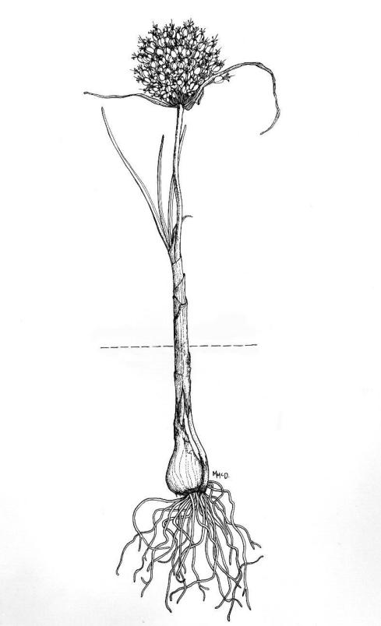
Tulips and narcissus provide little to nothing of forage value to pollinators.
Most of the native bulbs listed above are of no interest to deer, rabbits, etc, although sometimes squirrels inadvertently dig them up while squirrelling away food for the winter.

Look online for John Scheepers retail bulb catalog for more information and illustrations.

*Of particular interest to pollinators.

Devra He’ui Kitterman, March 2017

